**RECIPE SHARING PLATFORM**

**Introduction:**

The recipe sharing platform is a web-based application that allows users to create, edit, and delete recipes for dishes. It features a user-friendly interface, with recipes categorized by dish name, image, description, ingredients, and cooking time. Users can also engage with other users' recipes and manage their content through an admin dashboard.

**Technology Requirements:**

* Frontend: HTML, CSS, JavaScript
* Backend: Node.js, Express.js
* Database: MongoDB
* Design: Figma (for wireframing and UI Design)

**Modules:**

1. **User Authentication Module**

Handles user registration, login and session management.

1. **Post management Module**

Allows users to create, edit and delete recipes. Admins have additional privileges to manage all recipes posted.

1. **Search and filter Module**

Users can search recipes by title or categories and filter based on criteria

1. **Admin Dashboard**

Allows the admin to view and manage all recipes and users.

**Functionalities of each Module:**

1. **User Authentication Module**

* User registration and login.
* Password hashing for security.

1. **Post Management Module**

* Users can create recipes with a title, description and tags.
* Edit and delete options for user-created posts.
* Admins can delete any posts.

1. **Search and Filter module**

* Search functionality by title.
* Filter posts by categories.

1. **Admin dashboard**

* View all posts and user accounts.
* Manage and moderate content.

**Description of pages in the website:**

1. **Login Page**

* **Description:**

This page allows users to login to the platform itself. It includes fields for username and password. Upon successful login, users are redirected to their profile page. If they forget their password, they can click the “Forget password” link to reset it.

* **Key Features:**
* Username and password input fields.
* Link for “Forget password” that leads to the reset password page.
* Redirect to Profile Page upon successful login.
* Option to sign up if the user is new.

1. **Registration Page**

* **Description:**

This page allows users to sign up for the platform. Users can input their details such as username, name, email, and password. Upon successful registration, users can log in through login page.

* **Key Features:**
* Sign-up form with input fields for username, email and password.
* Redirect to login page after successful registration.

1. **Reset password page**

* **Description:**

This page is accesses via the “Forget password” hyperlink on the login page. It allows users to reset their password by providing their email or username, after which they receive an email to set new password.

* **Key Features:**
* Input field for email or username.
* Link to receive a password reset email.

1. **Home Page**

* **Description:**

The Home Page serves as the main page of the platform. From here, users can view the history of the website, the creators, the reasons and description of the website, popular recipes, popular users and a search bar to search recipes. Also, if the user is logged in there is a navigation bar that consists of options to view your profile.

* **Key Features:**
* History and social media information about the platform
* Button to check Profile Page.
* Search bar to search recipes.

1. **Profile Page**

* **Description:**

This page allows you to view your information, your recipes that you have uploaded and options to create new recipes and publish them, edit existing recipes, delete any unwanted recipes.

* **Key Features:**
* View existing recipes you have uploaded.
* View your profile information.
* Create new recipes and upload them
* Edit existing recipes to provide corrections or to add anything else
* Delete any recipes you would not like on your profile.

1. **Add Recipe Page**

* **Description:**

This page allows users to create new recipes and add to their profile. It consists of entry details from user such as

1. Recipe Title
2. Image (Optional)
3. Description
4. Ingredients
5. Instructions/Methods
6. Preparation and Cooking time
7. Cuisine Type, Nutritional Information, Tags (Optional)
8. Special note by the user (Optional)

* **Key Features:**
* Add new recipes to your profile
* Has many varieties of options to customize your recipe
* Can be detailed however you want it to be or simple one.

1. **Recipe view Page**

* **Description:**

When a user clicks to view a specific recipe, this page shows the full details of the selected recipe. Users can read the entire recipe and see related tags/categories.

* **Key Features:**
* Displays the full content of the recipe (Title, content, time etc)
* Links to edit or delete the blog (if the user is the author)

1. **Edit Recipe page**

* **Description:**

This page allows the user to edit an existing recipe page. The current content is filled in the input fields and users may make changes to the title, content, tags or any such information before saving the updates.

* **Key Features:**
* Form pre-filled with current recipe details.
* Option to update the title, content and tags.
* Button to save the edited recipe.

1. **Search recipe**

* **Description:**

This functionality allows users to search through available recipes by keywords, tags or categories. The results are displayed in a similar format to the homepage, that lists the matching recipes according to the input you gave in the search bar.

* **Key Features:**
* Search bar to input keyword or tags
* Displays a list of matching recipes based on the search criteria.

1. **Admin dashboard**

* **Description:**

This page is only accessible to admins if you enter the login details correctly on the login page, if it matches the admin credentials and once the admin has been logged in, then the admin can view all users in the database and delete them from the database as well.

* **Key Features:**
* Allows admin to view all the users in the platform
* Allows admin to delete users from the platform
* Admin may approve any recipes as to point a verified tag in the recipe.

**LOGIN PAGE:**

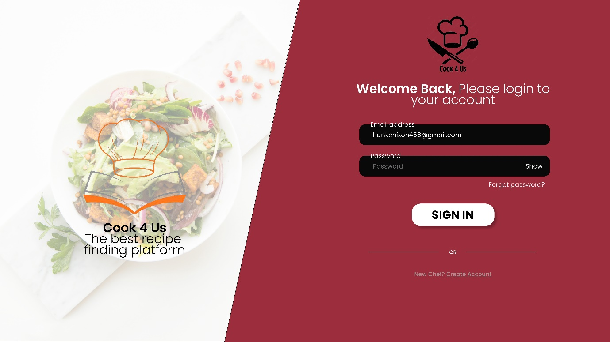

**REGISTRATION PAGE:**

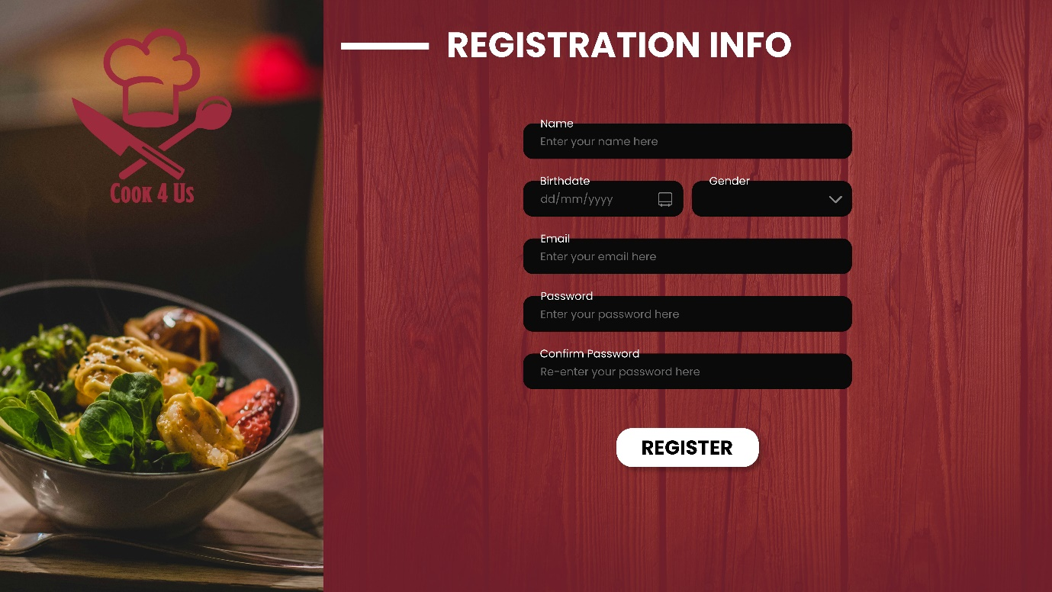

**RESET PASSWORD PAGE:**

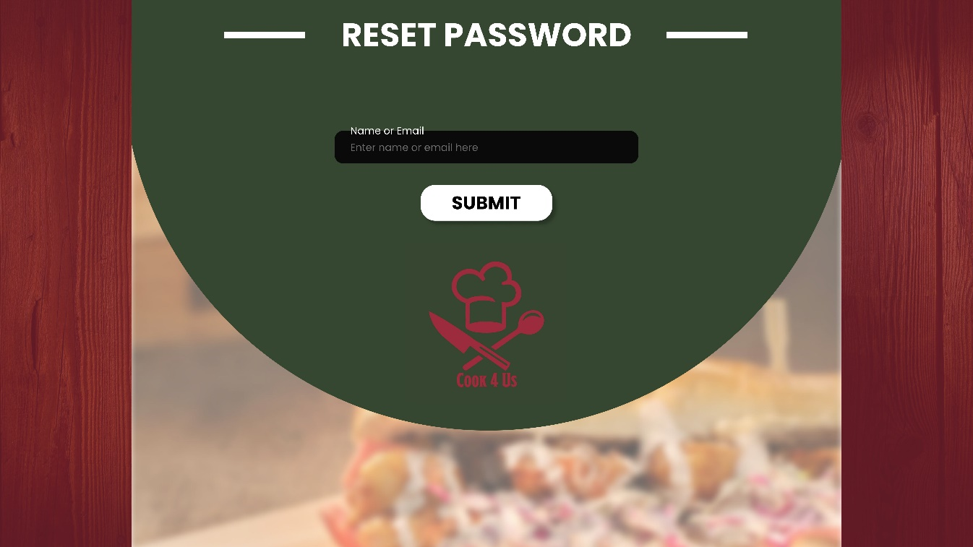

**HOME PAGE:**

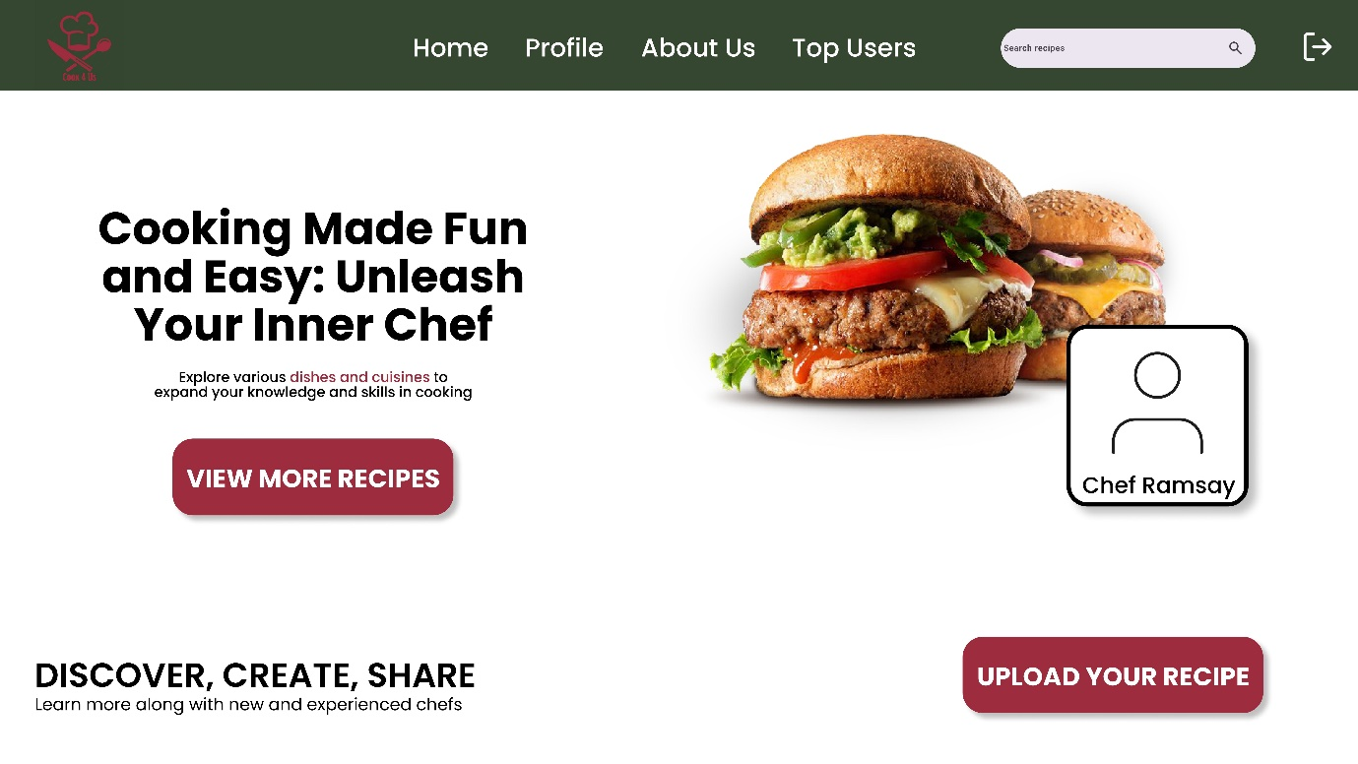

**PROFILE PAGE:**

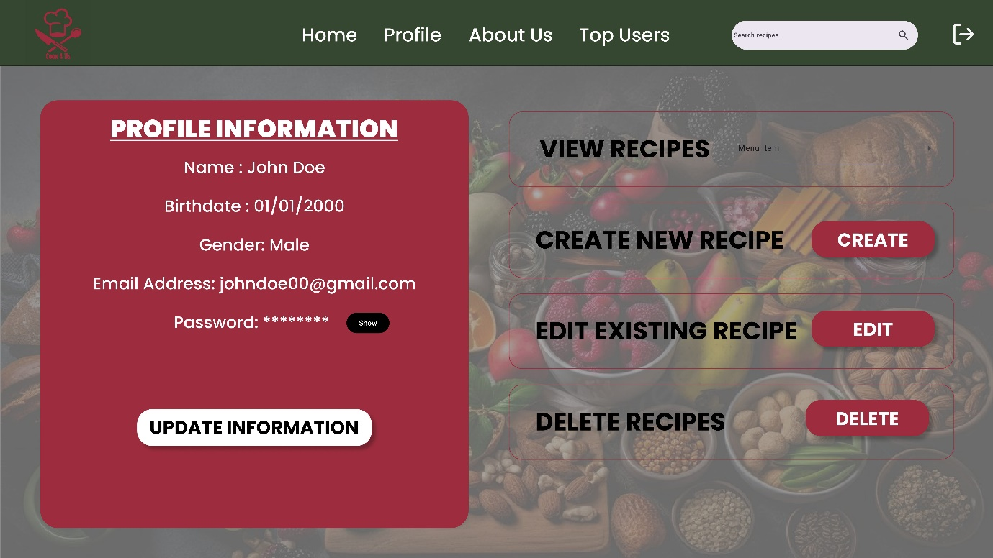

**ADD A RECIPE PAGE:**

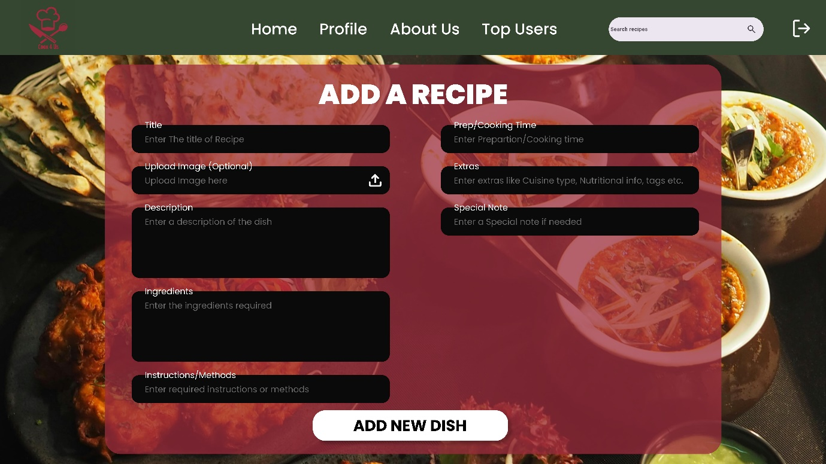

**VIEW DISH PAGE:**

